U.S. Democracy - Historical Context
This introductory course explores the key events, ideas, and institutions that shaped the emergence of American democracy, from colonial foundations through the Revolutionary era and the drafting of the Constitution. Designed for beginners, it provides a clear, accessible overview of how historical forces and political debates forged the democratic system we know today.

Audience: Individuals with little prior knowledge of U.S. history seeking an introductory understanding of the origins of American democracy.

Module 1: Introduction to Democracy

Topic 1 : What is Democracy?

Democracy
Democracy, derived from the Greek words demos (people) and kratos (power), means "rule by the people." It is considered one of the most important forms of governance because it empowers individuals, ensures accountability, and encourages participation.
Democracy is a system where power is vested in the hands of the people. However, in many organizations and governments, this takes the form of a representative democracy, or democratic republic, where people choose leaders or representatives to make decisions on their behalf rather than voting on every issue directly. Even when members do not vote on specific decisions, democratic systems are guided by principles such as representation, protection of individual rights, accountability, and opportunities for participation.

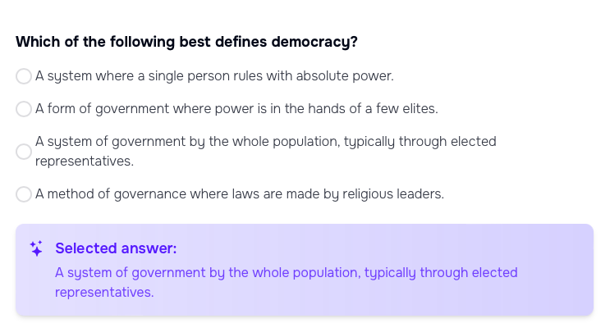

Topic 2: The Fundamentals of Democratic Principles

What are the Key Features of Democracy?

Key features of Democracy:
- Respect for Human Rights
- A multi-party system
- A democratic voting system
- Respect for Rule of Law
- 5. Democratic Governance
- Citizen participation

Topic 3 :The Importance of Democracy

Importance of Democracy
Democracy is a system where power is vested in the hands of the people. It is a mechanism that protects individual rights, ensures governmental accountability, and promotes active citizen participation.

Protection of Individual Rights
In a democracy, individual rights are paramount. These rights include freedom of speech, freedom of assembly, and the right to a fair trial. Governments in democratic countries are bound by a constitution that guarantees these rights.

Examples:
- The Bill of Rights (United States): The first ten amendments to the U.S. Constitution guarantee fundamental rights such as freedom of speech, religion, and press.
- Universal Declaration of Human Rights: This document, adopted by the United Nations, sets out fundamental human rights to be universally protected.

Accountability
Government officials in a democracy are accountable to the people. Democratic elections ensure that leaders are chosen by citizens and can be voted out if they fail to perform. This accountability helps prevent abuses of power.

Examples:
- Watergate Scandal (United States): This political scandal in the 1970s led to the resignation of President Richard Nixon and demonstrated the power of democratic institutions in holding leaders accountable.

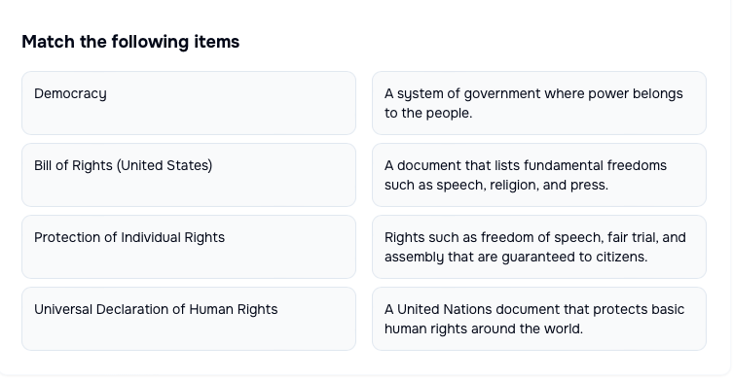

Topic 4: The participation of citizens

Participation
Democracy encourages the participation of citizens in decision-making processes. This participation is not limited to voting but extends to other forms of civic engagement like public debates, petitions, and protests.

The Civil Rights Movement in the United States is a strong example of participation because citizens actively worked to change unfair laws and fight for equality.
Ways citizens participated:
- Peaceful protests and marches: Thousands of people marched in events like the March on Washington to demand equal rights and draw attention to injustice.
- Boycotts: African Americans participated in the Montgomery Bus Boycott by refusing to ride buses, which put economic pressure on the system to end segregation.
- Sit-ins: Students sat at segregated lunch counters and refused to leave until they were served, challenging unfair rules.
- Public speeches and advocacy: Leaders like Martin Luther King Jr. gave speeches that inspired people and spread awareness.
- Working together for change: Ordinary citizens, not just leaders, joined together to demand fair treatment and equal rights.
Result of participation:
- Their actions helped lead to important laws, such as the Civil Rights Act of 1964 and the Voting Rights Act of 1965.
- This shows that citizen participation can influence government decisions and improve democracy.Practical Applications
- Voting: Understanding the importance of participating in elections to choose representatives and influence policy.
- Community Involvement: Engaging in local government meetings, community discussions, and public consultations to effect change.
- Advocacy: Using democratic channels to advocate for social, political, or environmental issues.

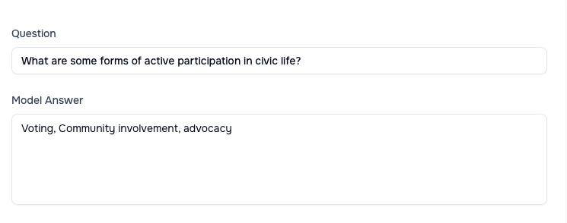

Module 2: The Historical Framework

Topic 1: The U.S. Constitution: Principles and Structure

The U.S. Constitution is the supreme law of the United States and the foundation of its democratic government. Created in 1787, it has since been a critical document in shaping American politics and society. Understanding its principles and structure is essential for grasping how the U.S. government operates and the reasoning behind its design.

Historical Context of the Constitution's Creation
After winning independence from Britain, the United States was initially governed by the Articles of Confederation, which proved ineffective due to the lack of a strong central government. The Constitutional Convention was convened in 1787 in Philadelphia to address these issues.
- Main Authors: Key figures included James Madison, Alexander Hamilton, and George Washington.
- Debates and Compromises: Major debates centered around state representation, with key compromises being the Great Compromise (resulting in a bicameral legislature) and the Three-Fifths Compromise.

Principles of the U.S. Constitution

Federalism
Federalism is the division of power between the national government and state governments. This principle ensures that both levels of government have specified powers, promoting a balance that prevents either from becoming too dominant.

Separation of Powers
The Constitution divides government powers among three branches: the legislative, executive, and judicial. Each branch has its own functions and responsibilities, designed to prevent any single branch from gaining too much power.
- Legislative Branch: Makes laws (Congress - House of Representatives and Senate).
- Executive Branch: Enforces laws (President).
- Judicial Branch: Interprets laws (Supreme Court and other courts).

Checks and Balances
This system ensures that each branch can monitor and limit the powers of the others. For example, the President can veto legislation, Congress can override vetoes and impeach the President, and the Supreme Court can declare laws unconstitutional.
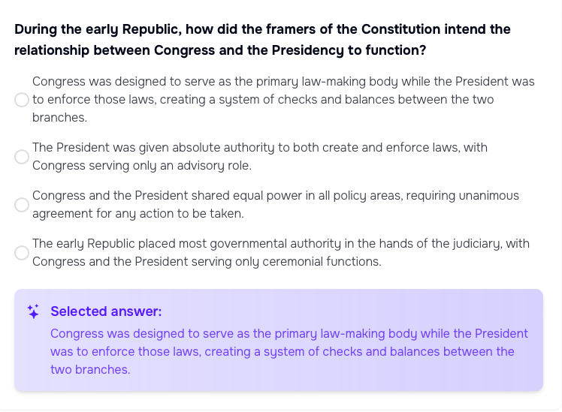

Topic 2: The Declaration of Independence

Historical Context
- Background: The mid-18th century saw growing tensions between the thirteen American colonies and Britain, primarily over issues of taxation and governance without representation.
- Continental Congress: In response to British policies, the colonies convened the First Continental Congress in 1774 and the Second Continental Congress in 1775, which eventually led to the Revolutionary War.

Main Authors
- Thomas Jefferson: The principal author of the Declaration, Jefferson was tasked with drafting the document due to his eloquence and strong advocacy for colonial rights.
- Committee of Five: The Declaration’s drafting involved a committee that included John Adams, Benjamin Franklin, Roger Sherman, Robert R. Livingston, and Thomas Jefferson.

Key Messages
- Preamble: The introduction outlines natural rights philosophy, emphasizing that all men are created equal with unalienable rights to life, liberty, and the pursuit of happiness.
- Grievances: Lists specific grievances against King George III, highlighting the colonies’ justification for independence due to the injustices suffered.
- Declaration of Independence: Asserted the colonies' right to be free and independent states, dissolving all political ties with Britain.

Impact on American Independence
- Motivation: The Declaration provided a clear and unified statement that motivated colonists and justified the rebellion.
- International Support: It helped in garnering international support, particularly from France, which was crucial for the success of the American Revolution.
- Foundation for Democracy: Established foundational principles of democracy and individual rights that would influence the U.S. Constitution and future democratic movements worldwide.

TASK

Topic 3 : Key Events Leading to Independence

December 16, 1773

The Boston Tea Party
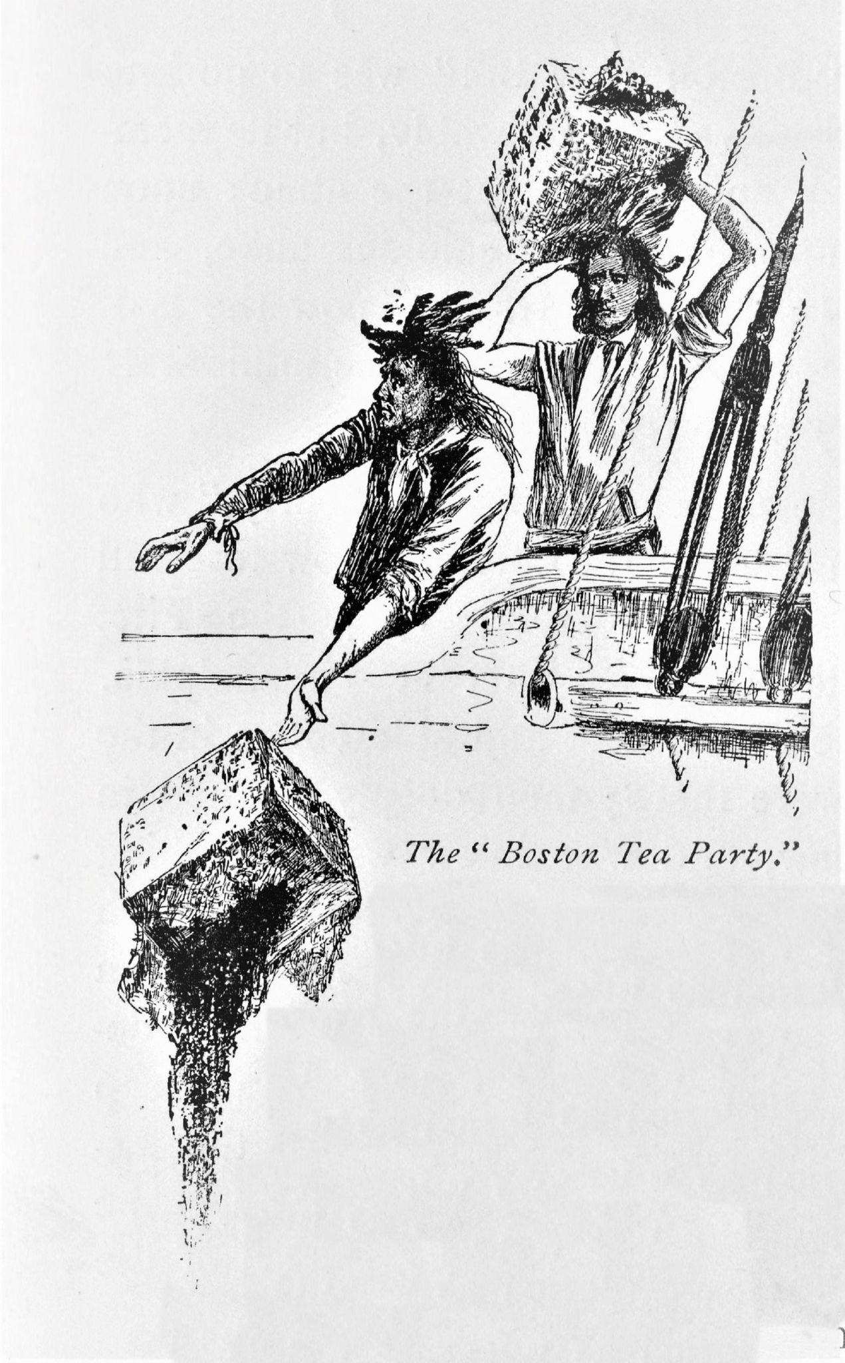

What Happened:
Colonists protested the British Tea Act by boarding three ships and dumping 342 chests of tea into Boston Harbor.
Why It Happened:
The Tea Act gave the British East India Company a monopoly on tea sales in the colonies. Colonists believed this was unfair taxation without representation.
Impact:
This bold act of resistance showed the colonies were willing to take drastic action against British policies.

2. 1774

The Intolerable Acts (Coercive Acts)
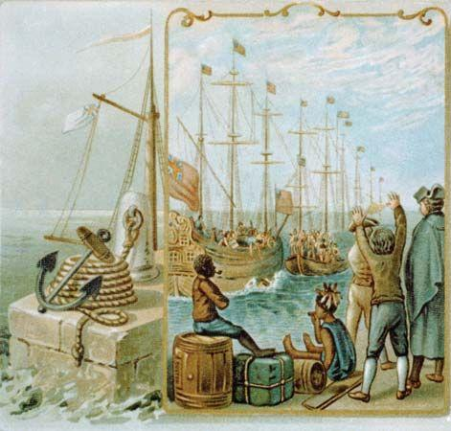
What Happened:
In response to the Boston Tea Party, Britain passed punitive laws to punish Massachusetts.
Key Laws Included:
- Boston Port Act – Closed Boston Harbor
- Massachusetts Government Act – Limited town meetings
- Administration of Justice Act – Protected British officials
- Quartering Act – Required colonists to house British troops
Impact:
Instead of isolating Massachusetts, these acts united the colonies in opposition to British rule.

3. September 1774

The First Continental Congress
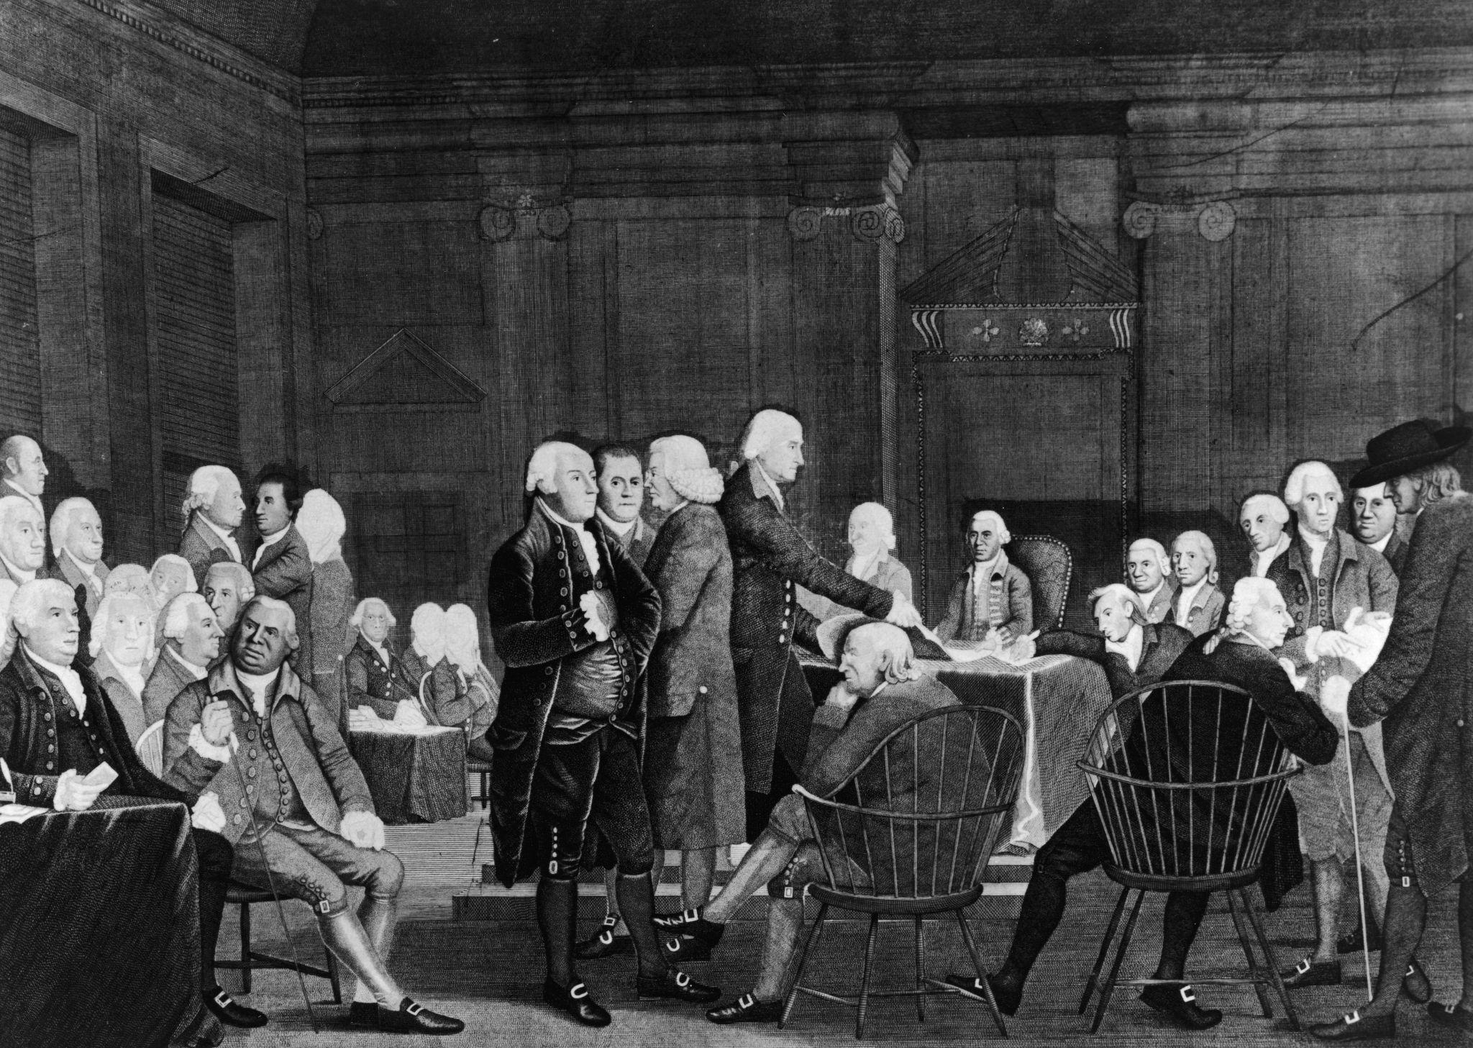
What Happened:
Delegates from 12 of the 13 colonies met in Philadelphia to discuss how to respond to British actions.
What They Did:
- Declared colonial rights
- Organized boycotts of British goods
- Began preparing for possible military resistance
Impact:
This marked the first unified colonial response and laid the foundation for the American Revolution.

Task : Put events into correct order

Module 3: The Importance of History in Understanding Modern Civic System

Topic 1: Key Historical Milestones Shaping Civic Life
Understanding today’s civic system requires a grasp of several pivotal events in U.S. history. Below is a concise overview of four major milestones, presented at a basic level.
Milestone | Timeframe | Core Development | Impact on Civic Life
Civil War | 1861‑1865 | Armed conflict between the Union (Northern states) and the Confederacy (Southern states) over slavery and states’ rights. | Ended the legal institution of slavery and set the stage for constitutional amendments that expanded citizenship rights.
Reconstruction | 1865‑1877 | Post‑war period focused on reintegrating the seceded states and guaranteeing civil rights for formerly enslaved people, most notably through the 13th, 14th, and 15th Amendments. | Established federal protection of voting rights and equal protection under the law, though many gains were later eroded by Jim Crow laws.
The New Deal | 1933‑1939 | A series of federal programs and reforms introduced by President Franklin D. Roosevelt to combat the Great Depression. Key components include Social Security, unemployment insurance, and regulatory agencies such as the SEC. | Expanded the role of the federal government in economic and social welfare, creating a modern partnership between citizens and the state.
Voting Rights Act of 1965 | 1965 (enacted) | Landmark civil‑rights legislation that prohibited racial discrimination in voting, enforced the 15th Amendment, and introduced federal oversight of jurisdictions with histories of voting suppression. | Secured broader, more equitable participation in elections, reinforcing the principle of “one person, one vote.”
These events collectively forged the legal and institutional foundations of contemporary American democracy, influencing how citizens engage with government, exercise their rights, and shape public policy.

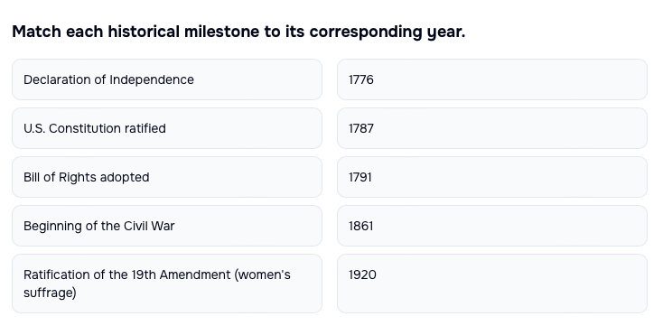

Topic 2: Lessons from Past Crises and Reforms
Throughout U.S. history, major crises have often led to important changes in the government and society. Two major examples are the Great Depression and the Civil Rights Movement.

The Great Depression (1929–1939)
What Happened:
During the Great Depression, banks failed, businesses closed, and millions of Americans lost their jobs. People lost confidence in the economy and the government needed to respond.
Key Changes:
- The New Deal: Programs created to help people find jobs and rebuild the economy.
- FDIC and SEC: Agencies created to protect bank deposits and regulate the stock market.
- Social Security: Help for retired workers and people in need.
Impact:
The government began playing a bigger role in protecting people’s economic security.

The Civil Rights Movement (1950s–1960s)
What Happened:
African Americans and their supporters protested against racial discrimination, segregation, and unfair voting laws.
Key Changes:
- Civil Rights Act of 1964: Banned discrimination in jobs, schools, and public places.
- Voting Rights Act of 1965: Protected the right to vote and removed unfair voting barriers.
- EEOC: An agency created to enforce equal employment laws.
Impact:
These laws helped protect equality and made democracy more fair for all citizens.

Why Crises Lead to Reform
- Public pressure: People demand change during hard times.
- Opportunity for new policies: Leaders are more open to new solutions.
- Restoring trust: Reforms help rebuild confidence in the government.

✅ Takeaway:
Major challenges often push the United States to improve its laws and institutions, helping democracy become stronger and more inclusive over time.

Topic 3: Applying Historical Insight to Contemporary Issues

Why History Helps Us Understand Today
Learning about past reforms in American democracy helps us understand current issues like climate policy and voting rights.

Why History Matters
- Core ideas like equal rights and government by the people guide reforms over time.
- The Constitution can change through amendments, such as the 13th Amendment (ended slavery) and 19th Amendment (women gained the right to vote).
- History shows how cooperation and public pressure help pass new laws.

Past Reforms and Climate Policy
Earlier reforms show the government can step in to protect people.
For example, Progressive Era regulations and New Deal programs improved public safety and created jobs. These ideas influence today’s climate and green-energy policies.

Voting Rights Then and Now
- The 14th and 15th Amendments protected citizenship and voting rights.
- The Voting Rights Act of 1965 helped stop unfair voting practices.
These laws help guide today’s debates about voting access and election rules.
✅ Takeaway:
History helps us understand how democracy changes and gives us lessons for solving today’s problems.


